Payeer for CMS Invision Power Suite 4

Copy the applications folder in the site root via FTP or SSH client (if necessary, replace the files and folders)
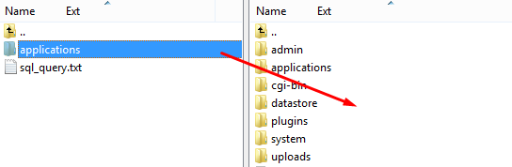

Open the file sql_query.txt and copy the contents.
Run the SQL query to the database, which is installed CMS IPS4.
The request may be made through a SQL client or phpMyAdmin (to paste the copied text from the file sql_query.txt)
If the database exists prefix, append it to the word "core_sys_lang_words" and confirm the query.
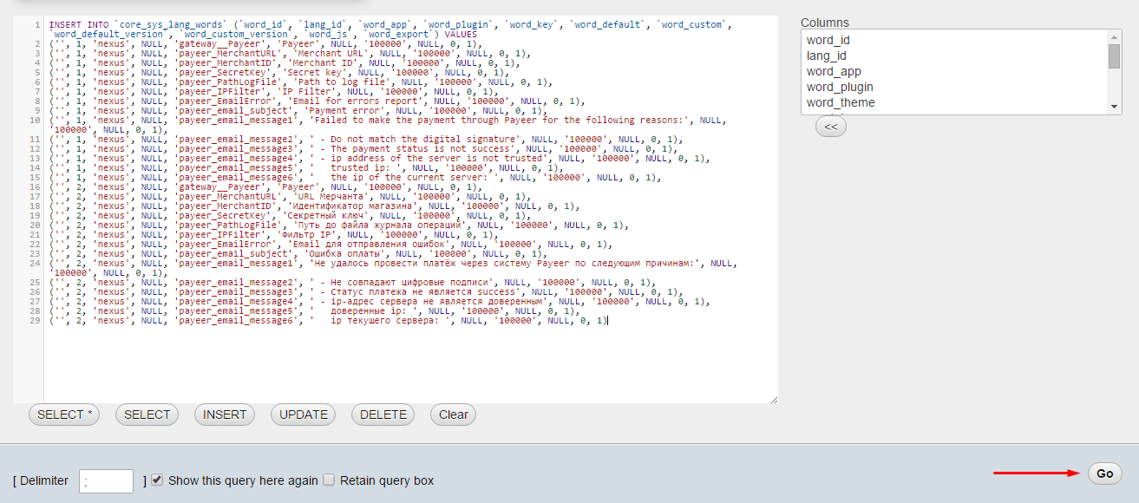

Open «AdminCP → Commerce → Settings»
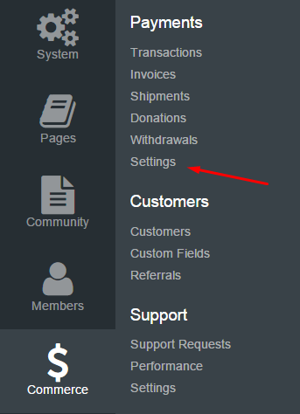

In the tab "Payment Methods" create a new pay type
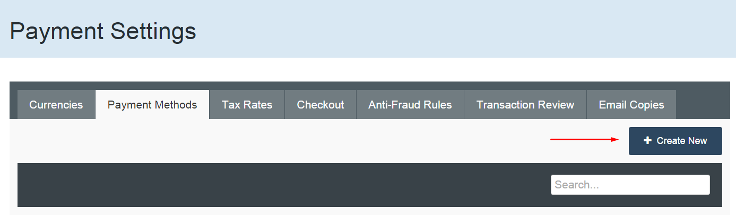
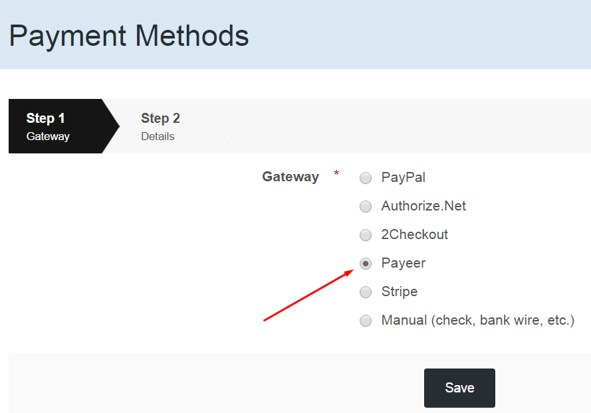
Select a payment gateway "Payeer" and click "Save"
In the second step, fill in the parameters of the payment method.
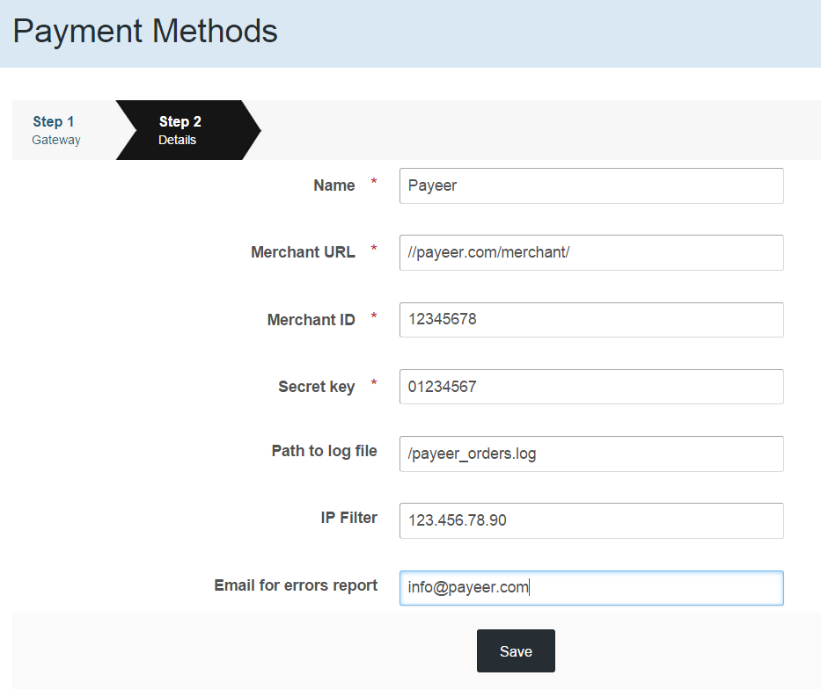

- URL of the merchant, the default way to pay //payeer.com/merchant/ (change only if an information notice from payeer.com about the change in payment URL)
- Enter your store identifier, obtained by creating a store in the personal cabinet payeer.com
- Specify the secret key that is associated with the store, registered in payeer.com
- Specify the path to the file log, and all information payments via Payeer will be recorded in this file. If left blank, the entry will not occur

- In the ip filter you can specify a list of trusted ip addresses of servers separated by commas. You can also specify a mask instead of an ip address. If the field is left empty, then checking for trusted ip addresses is not performed.
For example:
192.168.71.87, 192.165.83.17, 192.178.34.15
Or 192.*.71.87, 192.165.83.*, 192.*.34.15
Or *.*.*.* - available to all ip addresses
- Enter your email address, which will receive notices in the event of a payment error. The letter will state the reason and basic information about the payment.
Click "Save".
A new type of payment Payeer should appear in the list of available.

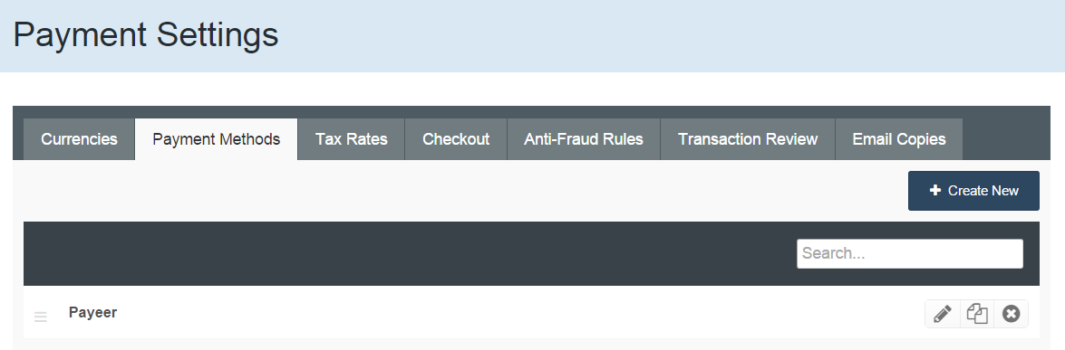

Then, specify the URL address in «Account Payeer → Merchant → Settings»

Success URL:
http://**********/applications/nexus/interface/gateways/payeer/success.php
Fail URL:
http://**********/applications/nexus/interface/gateways/payeer/fail.php
Status URL:
http://**********/applications/nexus/interface/gateways/payeer/status.php
where********** - your domain

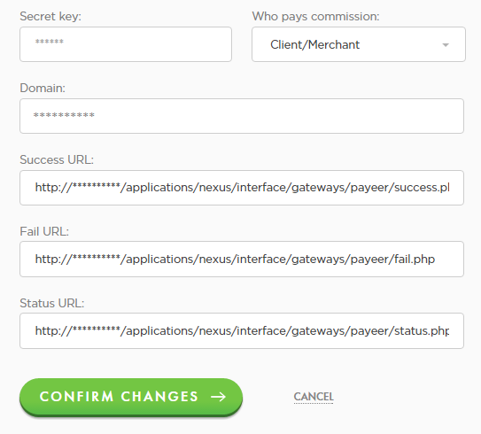

Then "Confirm changes", enter the Master key (if required) and save.
Module Payeer for CMS Invision Power Suite 4 configured.

